Roll no: 241701021

Experiment 9

Aim:
To design and configure a simple network consisting of a router, switch, access point, and multiple wired and wireless end devices, and to verify communication between them.
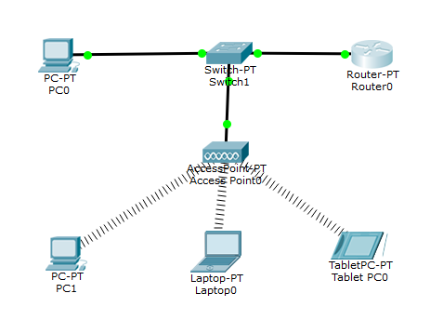
Components Required:
- 1 Switch
- 2 PC
- 1 Laptop
- 1 Access point
- 1 Tablet
- Copper straight through

Procedure:
- Add Devices
  - Place the following devices in the workspace:
    - 1 Router (Router0)
    - 1 Switch (Switch1)
    - 1 Access Point (Access Point0)
    - 1 Wired PC (PC0)
    - Wireless devices: PC1, Laptop0, TabletPC0
- Connect Devices (Wired)
  - Connect PC0 → Switch1 using a straight-through cable.
  - Connect Switch1 → Router0 using a straight-through cable.
  - Connect Switch1 → Access Point0 using a straight-through cable.
- Configure Router
  - Assign an IP address to the router interface (e.g., 192.168.1.1).
  - Enable the interface.
- Configure Switch
  - No major configuration required (default settings are sufficient).
  - Ensure all ports are active.
- Configure Access Point
  - Set SSID (e.g., "WirelessLAN").
  - Configure security (WPA2-PSK with a password).
  - Assign IP address if required (or use DHCP).
- Configure End Devices
  - PC0 (wired):
    - Assign IP manually (e.g., 192.168.1.2, subnet mask 255.255.255.0, gateway 192.168.1.1)
  - Wireless Devices (PC1, Laptop0, TabletPC0):
    - Connect to the SSID created on the access point.
    - Enter password.
    - Assign IP manually or via DHCP (e.g., 192.168.1.3–192.168.1.5)
- Verify Connectivity
  - Use the ping command:
    - From PC0 to Router0
    - Between wired and wireless devices
    - Between wireless devices
Observation:

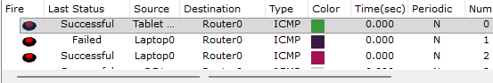

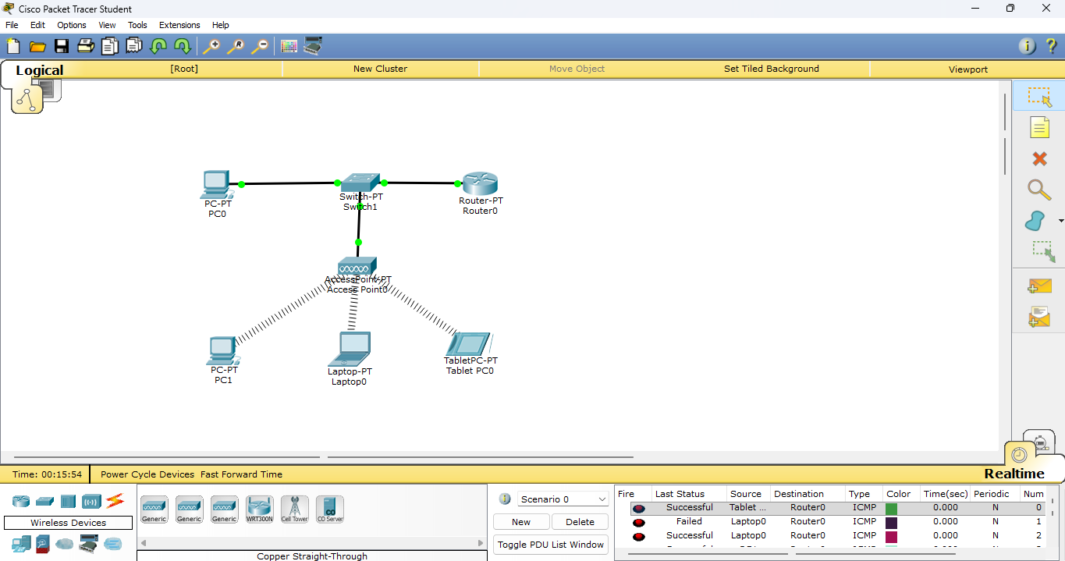
fig. Final circuit

Result:
The network was successfully created and configured. All wired and wireless devices were able to communicate with each other.

